LAPORAN TUGAS KELOMPOK

PRAKTIKUM DASAR PEMROGRAMAN

ARRAY 2 DIMENSI

Oleh:

|  |  |
| --- | --- |
| ALI SAFIK  MOCHAMMAD SYAIFUDDIN ZUHRI  NADIA LAYRA AZIZA  SESHA DWI LESTARI | 1941720066  1941720013  1941720061  1941720173 |



PROGRAM STUDI D-IV TEKNIK INFORMATIKA

JURUSAN TEKNOLOGI INFORMASI

POLITEKNIK NEGERI MALANG

16 NOVEMBER 2019

**ARRAY 2 DIMENSI**

**SOAL G**

1. **FLOWCHART**

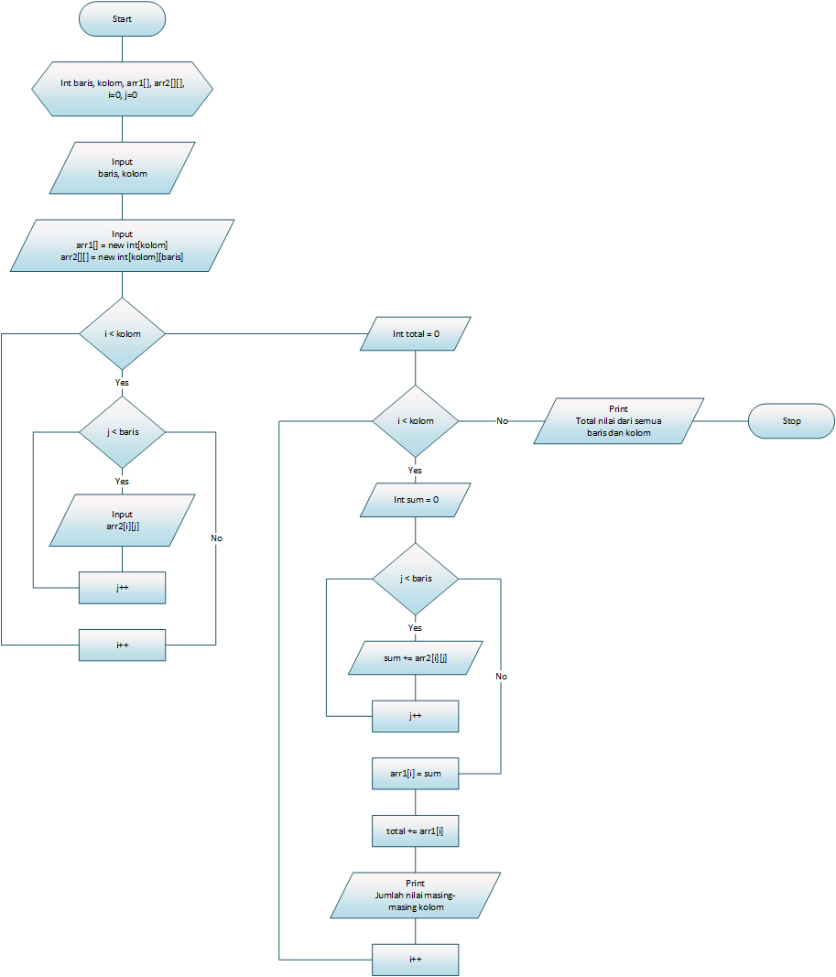

1. **SOURCE CODE**

|  |  |
| --- | --- |
| 1 | package TugasArray2D; |
| 2 |  |
| 3 | import java.util.Scanner; |
| 4 |  |
| 5 | public class soal_G { |
| 6 | public static void main(String[] args) { |
| 7 |  |
| 8 | Scanner angka = new Scanner (System.in); |
| 9 |  |
| 10 | System.out.print("Jumlah Baris : "); |
| 11 | int baris = angka.nextInt(); |
| 12 | System.out.print("Jumlah Kolom : "); |
| 13 | int kolom = angka.nextInt(); |
| 14 |  |
| 15 | int arr1[] = new int[kolom]; |
| 16 | int arr2[][] = new int[kolom][baris]; |
| 17 |  |
| 18 | for (int i=0; i<kolom; i++){ |
| 19 | for (int j=0; j<baris; j++){ |
| 20 | System.out.print("Input baris ke-"+(j+1)+" kolom ke-"+(i+1)+" : "); |
| 21 | arr2[i][j] = angka.nextInt(); |
| 22 | } |
| 23 | System.out.println(""); |
| 24 | } |
| 25 |  |
| 26 | int total=0; |
| 27 | for (int i=0; i<kolom; i++){ |
| 28 | int sum=0; |
| 29 | for (int j=0; j<baris; j++){ |
| 30 | sum += arr2[i][j]; |
| 31 | } |
| 32 | arr1[i] = sum; |
| 33 | total += arr1[i]; |
| 34 | System.out.println("Jumlah nilai kolom ke-"+(i+1)+" : "+arr1[i]); |
| 35 | } |
| 36 |  |
| 37 | System.out.println("Total nilai semua baris dan kolom : "+total); |
| 38 |  |
| 39 | } |
| 40 | } |

1. **OUTPUT**

